let's state the procedure in terms of performing a proportion test using the *p*-value approach. The basic procedure is:

1. State the null hypothesis *H*0 and the alternative hypothesis *HA*.
2. Set the level of significance *α*.
3. Calculate the test statistic:
4. 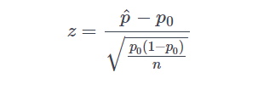
5. Calculate the *p*-value.
6. Make a decision. Check whether to reject the null hypothesis by comparing *p*-value to *α*. If the *p*-value < *α* then reject *H*0; otherwise do not reject *H*0.

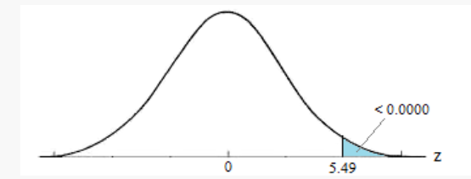  
Our Conclusion: Because the *p*-value is smaller than the significance level *[Math Processing Error]α=0.05*, we can reject the null hypothesis. Again, we would say that there is sufficient evidence to conclude boys are more common than girls in the entire population at the *[Math Processing Error]α=0.05* level.

As should always be the case, the two approaches, the critical value approach and the *p*-value approach lead to the same conclusion.